SQL Queries for Pizza Sales Dataset:

1. KPI’s
2. SELECT SUM(total_price) AS Total_Revenue from [ Pizza_salses ]

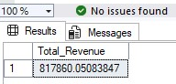

1. SELECT SUM(total_price) / Count(DISTINCT order_id) as Avg_Order_value from [ Pizza_salses ]

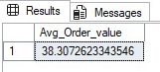

1. SELECT SUM(quantity) AS Total_Pizza_Sold from [ Pizza_salses ]

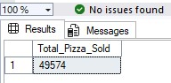

1. SELECT COUNT(DISTINCT order_id) AS Total_Orders from [ Pizza_salses ]

1. SELECT CAST(SUM(quantity) AS DECIMAL (10,2)) /

CAST(COUNT(DISTINCT order_id) AS DECIMAL(10,2)) AS Avg_Pizzas_per_order from [ Pizza_salses ]

1. Charts
2. SELECT DATENAME(DW, order_date) as order_day, COUNT(DISTINCT order_id) AS Total_orders from [ Pizza_salses]

GROUP BY DATENAME(DW, order_date)

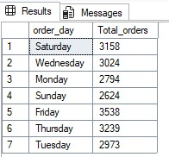

1. SELECT DATENAME(MONTH, order_date) as Month_Name, COUNT(DISTINCT order_id) AS Total_orders from [ Pizza_salses]

GROUP BY DATENAME(MONTH, order_date)

ORDER BY Total_orders DESC

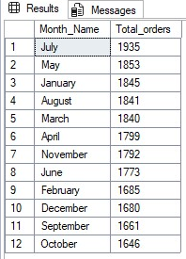

3. SELECT pizza_category, sum(total_price) as Total_sales, sum(total_price) * 100 /

( SELECT sum(total_price) from [ Pizza_salses ] WHERE MONTH(order_date)=1) AS PCT

from [ Pizza_salses ]

WHERE MONTH(order_date)=1

GROUP BY pizza_category

ORDER BY PCT, Total_sales DESC

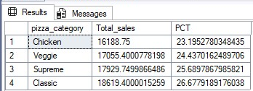

4. SELECT pizza_size, sum(total_price) as Total_sales, sum(total_price) * 100 /

( SELECT sum(total_price) from [ Pizza_salses ]) AS PCT

from [ Pizza_salses ]

GROUP BY pizza_size

ORDER BY PCT DESC

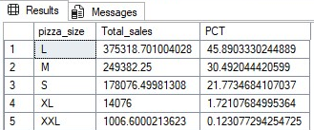

5.SELECT TOP 5 pizza_name, SUM(total_price) AS Total_Rvenue FROM [ Pizza_salses ]

GROUP BY pizza_name

ORDER BY Total_Rvenue DESC

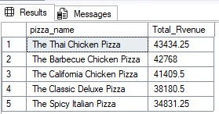

6. SELECT TOP 5 pizza_name, SUM(total_price) AS Total_Rvenue FROM [ Pizza_salses ]

GROUP BY pizza_name

ORDER BY Total_Rvenue ASC

7. SELECT TOP 5 pizza_name, SUM(quantity) AS Total_quantity FROM [ Pizza_salses ]

GROUP BY pizza_name

ORDER BY Total_quantity DESC

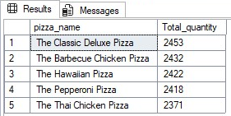

8. SELECT TOP 5 pizza_name, SUM(quantity) AS Total_quantity FROM [ Pizza_salses ]

GROUP BY pizza_name

ORDER BY Total_quantity ASC

